**In Kali Terminal**

**┌──(kali㉿kali)-[~]**

**└─$ ifconfig**

eth0: flags=4163<UP,BROADCAST,RUNNING,MULTICAST> mtu 1500

inet 192.168.27.131 netmask 255.255.255.0 broadcast 192.168.27.255

inet6 fe80::6c8d:3ebd:4a00:5c4e prefixlen 64 scopeid 0x20<link>

ether 00:0c:29:d1:aa:d1 txqueuelen 1000 (Ethernet)

RX packets 696 bytes 375514 (366.7 KiB)

RX errors 0 dropped 0 overruns 0 frame 0

TX packets 723 bytes 76748 (74.9 KiB)

TX errors 0 dropped 0 overruns 0 carrier 0 collisions 0

device interrupt 19 base 0x2000

lo: flags=73<UP,LOOPBACK,RUNNING> mtu 65536

inet 127.0.0.1 netmask 255.0.0.0

inet6 ::1 prefixlen 128 scopeid 0x10<host>

loop txqueuelen 1000 (Local Loopback)

RX packets 2216 bytes 332559 (324.7 KiB)

RX errors 0 dropped 0 overruns 0 frame 0

TX packets 2216 bytes 332559 (324.7 KiB)

TX errors 0 dropped 0 overruns 0 carrier 0 collisions 0

**In Windows Command Prompt**

**C:\Users\student>ipconfig**

Windows IP Configuration

Ethernet adapter Ethernet:

Connection-specific DNS Suffix . :

IPv4 Address. . . . . . . . . . . : 172.16.225.3

Subnet Mask . . . . . . . . . . . : 255.255.0.0

Default Gateway . . . . . . . . . : 172.16.225.254

Ethernet adapter VirtualBox Host-Only Network:

Connection-specific DNS Suffix . :

IPv4 Address. . . . . . . . . . . : 192.168.56.1

Subnet Mask . . . . . . . . . . . : 255.255.255.0

Default Gateway . . . . . . . . . :

Wireless LAN adapter Wi-Fi:

Media State . . . . . . . . . . . : Media disconnected

Connection-specific DNS Suffix . :

Wireless LAN adapter Local Area Connection* 1:

Media State . . . . . . . . . . . : Media disconnected

Connection-specific DNS Suffix . :

Wireless LAN adapter Local Area Connection* 2:

Media State . . . . . . . . . . . : Media disconnected

Connection-specific DNS Suffix . :

Ethernet adapter VMware Network Adapter VMnet1:

Connection-specific DNS Suffix . :

IPv4 Address. . . . . . . . . . . : 192.168.153.1

Subnet Mask . . . . . . . . . . . : 255.255.255.0

Default Gateway . . . . . . . . . :

Ethernet adapter VMware Network Adapter VMnet8:

Connection-specific DNS Suffix . :

IPv4 Address. . . . . . . . . . . : 192.168.27.1

Subnet Mask . . . . . . . . . . . : 255.255.255.0

Default Gateway . . . . . . . . . :

Ethernet adapter Bluetooth Network Connection:

Media State . . . . . . . . . . . : Media disconnected

Connection-specific DNS Suffix . :

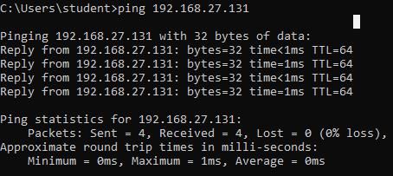

**To block the IP Packets**

┌──(kali㉿kali)-[~]

└─$ **sudo iptables -A INPUT -s 192.168.27.1 -j DROP**

[sudo] password for kali:

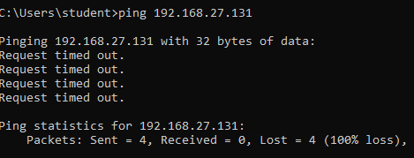

**To unblock the IP Packets**

┌──(kali㉿kali)-[~]

**└─$ sudo iptables -D INPUT -s 192.168.27.1 -j DROP**

[sudo] password for kali:

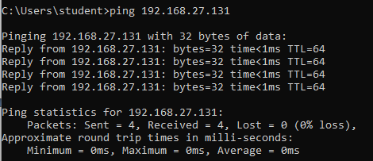

**To block the port 80**

┌──(kali㉿kali)-[~]

**└─$ sudo iptables -A INPUT -s 192.168.27.1 -p tcp --destination-port 80 -j DROP**

In windows browser search for kali ip address

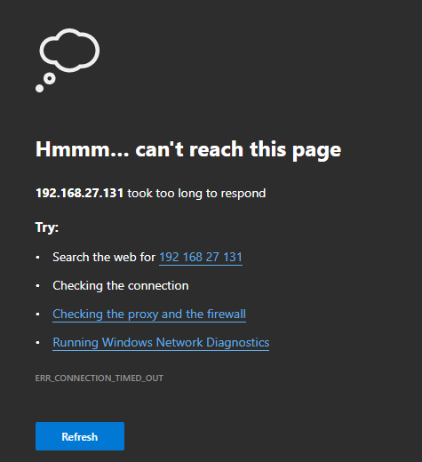

**To unblock the port 80**

┌──(kali㉿kali)-[~]

└─$ **sudo iptables -D INPUT -s 192.168.27.1 -p tcp --destination-port 80 -j DROP**

In windows browser search for kali ip address apache2 default page will be opened.

